George Whiting - Developer

03/04/2018

Project brief for client Jennifer viala – Brooklyn’s Outdoor film Festival Website

# **Summary**

The client, Jennifer Viala founder of Brooklyn Vibes Event Co aims to select films and show them at this year’s Brooklyn Outdoor Film Festival. She hopes to show films from August 5th to August 8th at the Brooklyn Bridge Park in New York. She wants the event to appeal to all audiences of all ages, this needs to be conveyed through her publications. She also needs to communicate online about the festival, so she needs a website to carry out this task.

The website itself needs to contain information about the venue and festival, it also needs to allow users to access her various social media platforms and view news and updates regarding the festival. A crucial requirement is the ability for the website to take reservations as the venue capacity is 5,000. This needs to be done via a reservation/register form on the website.

# **Stakeholders**

|  |  |
| --- | --- |
| **Name of Stakeholder** | **Role** |
| George Whiting | Web Developer |
| Jennifer Viala | Client/CEO/founder of Brooklyn Vibes Events Co |
| Brooklyn Bridge Park | Venue |

# **Goals**

During this project there will be several goals to meet in order to achieve what the client has asked. I will now go through them in detail.

## Create and aesthetically pleasing website on all devices with a sense of brand identity throughout

This goal will guide the visuals of the website design, the website should be clean, uncluttered and easy to access for all ages and audiences, as per the clients instructions. This will be achieved using good CSS and by utilizing Bootstraps responsive design suited for display on a range of devices. Care should also be taken when using images, ensuring they are suitable and placed correctly. Brand identity should be achieved with the use of color and elements layout.

## Create a registration page for attendees to secure a place at the festival

The client has asked for the ability to allow attendees to register their place at the festival, this is essential as the venue capacity has a limit of 5,000 people. The Registration form will collect personal details such as forename surname name and email address and the least. At this stage the registration form does not need to be functional.

## Include client requested links and social media button links within the website

The client has requested the inclusion of links to two external websites; Brooklyn News and the Brooklyn Bridge Park website. These will be included in the header/navbar on all pages. The client has also requested that there be links to her Twitter, Facebook and Instagram pages as well. A link to a relevant YouTube video will also be included, these shall all be implemented within the footer.

## Implement the specific client requested pages within the website

The client has asked for several key pieces of information to be included within the website design. These include the aforementioned register feature, information about the festival, news and publications regarding the festival and the films being shown. All of these requests will be implemented within their own independent pages.

## Obtain the requested web address URL for the website

The client has asked for a .com or .org web address, I propose we go for [www.brooklynfilmfestival.com](http://www.brooklynfilmfestival.com) I have dropped the ‘Outdoor’ part as otherwise the URL would be too long and counterproductive when attracting people to the website. This proposed URL accurately describes what it is without being too long or forgettable.

## To deliver a fully tested first version website within 3 weeks

The client has asked for a first version website to be delivered. This website shall be tested before delivering, for example; links tested, ensuring the website and content displays correctly on all screen sizes and load times are acceptable and to generally deliver a functioning first version website within a 3 week time frame.

# **Budget**

The client has a budget of **$3,500** to get the website up and running. This budget will be split across the core costs and the rest put aside for unexpected or sneaky expenses. I will detail these below.

|  |  |
| --- | --- |
| **Cost** | **How Much?** |
| Web Hosting | Using go-daddy and selecting the required package, **$192.18** |
| URL Domain Address | **Free**, with go-daddy hosting package |
| Developer Rates | 3 weeks at $100.00 a day = **$1,500** |
| Facebook Ads that link to the Website | I suggest running the ad over the month prior to the festival to generate traffic to the website, with an ad budget of **$500** |
| Operational expenses, e.g. travel, **image licenses** and other promotional material. | **$1,307.82** |
| **Total Spent:** | **$3,500** |

# **Timeline**

As developer of the proposed website, I intend to complete the website within 3 weeks, the timeline below will show how that time is to be split.

|  |  |  |  |
| --- | --- | --- | --- |
| **Main Stage** | **Time Frame** | **Sub stages** | **Timeframe** |
| **Create Basic Layout for Website** | 17 Hours | **Complete Mock-Up** | 10 Hours |
| **Implement Nav-Bar** | 1 Hour |
| **Implement Footer** | 1 Hour |
| **Select wallpaper** | 1 Hour |
| **Add External Links** | 1 Hour |
| **Create Basic CSS file** | 3 Hours |
|  | | | |
| **Add Pages to Website** | 4 Hours | **Add About Page** | 1 Hour |
| **Add Films Page** | 1 Hour |
| **Add News Page** | 1 Hour |
| **Add Register Page** | 1 Hour |
|  | | | |
| **Add Page Content** | 21 Hours | **Gather Images** | 3 Hours |
| **Research Brooklyn Bridge Park** | 2 Hours |
| **Obtain Google Maps embed code** | 1 Hour |
| **Obtain Brooklyn Bridge Park twitter account embed widget/code** | 1 Hour |
| **Add About Content** | 4 Hours |
| **Add Film Content** | 4 Hours |
| **Add News Content** | 4 Hours |
| **Add Register Form** | 2 Hours |
|  | | | |
| **Set Color/Brand Identity** | 6 Hours | **Select Font from Google Fonts** | 1 Hour |
| **Choose a primary color for website elements** | 1 Hour |
| **Implement in CSS** | 4 Hours |
|  | | | |
| **Test Website** | 6 Hours | **Test Links** | 1 Hour |
| **Spell/Grammar Check** | 1 Hour |
| **Test Responsiveness on various screen sizes** | 1 Hour |
| **Test Load Times** | 1 Hour |
| **Cross browser Compatibility Check** | 2 Hours |
| **Total Time:**  **54** hours or **3 weeks** at around **20 hours** work per week allowing for an extra **6** hours if needed | | | |

# **Technical Specification**

I will now go through some of the design choices and technical choices that I made prior and during this project, I shall list them and then explain in further detail below, I have used screenshots to further illustrate the specification.

## Using bootstrap grid for responsive design

In order to get the website working as intended on all devices and screen sizes I made full use of the Bootstrap grid layout. The Bootstrap grid allows me to develop the website with responsiveness in mind, by using the grid the website automatically resizes depending on the screen size of the user, allowing the layout to change responsively. See screenshots below for an example.

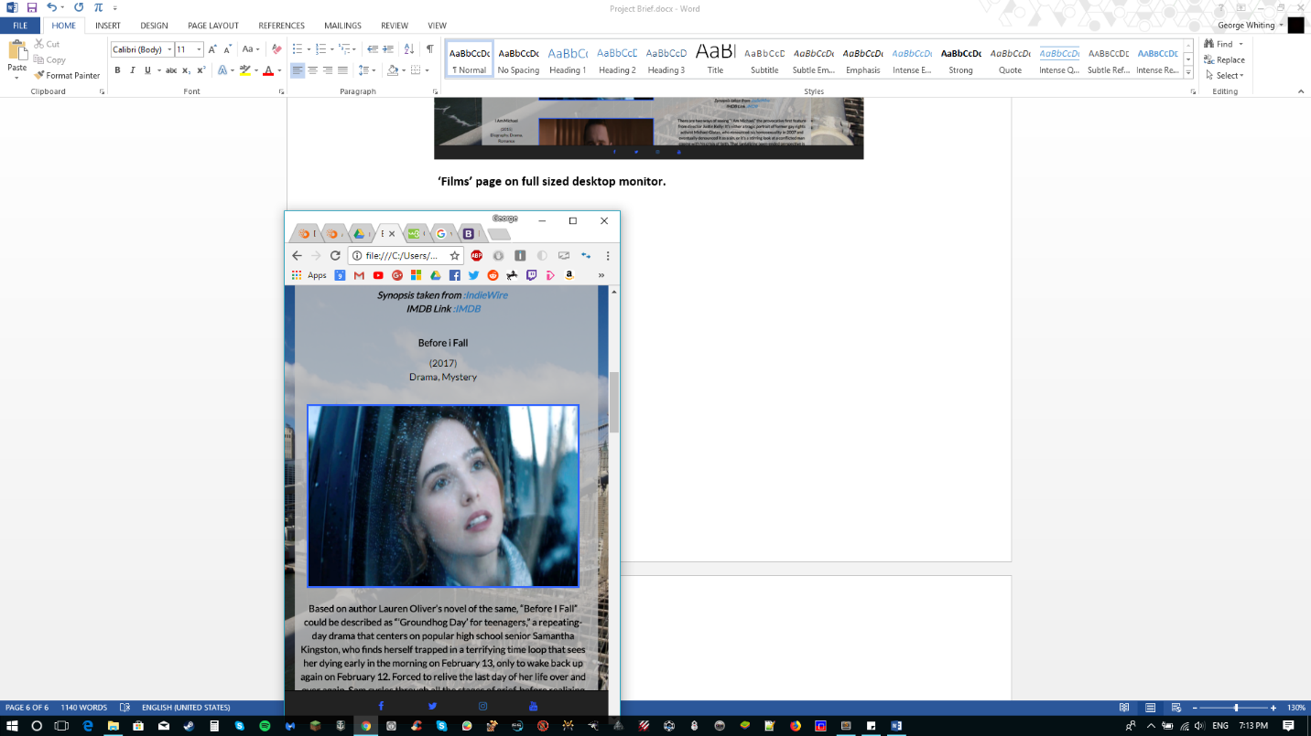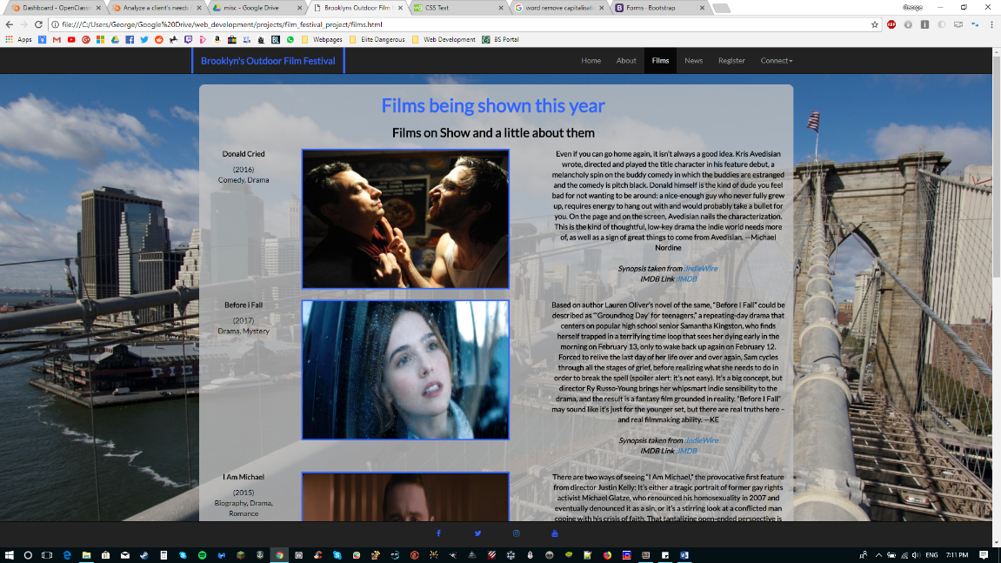

**‘Films’ page on full sized desktop monitor Same page on mobile.**

Notice how the layout has changed to position the elements in a vertical order, allowing easy reading on a smartphone. This is done by using the 12 columns within the grid, for example on a large screen each element may take up 3 columns, which places them side by side, on a smartphone sized screen , they take up all 12 columns which push the next element onto a different row, giving the vertical appearance.

## Implementing a clean and uncluttered design

This specification is crucial to the usability of the website, it is also crucial for any website on the internet. I kept my website clean and uncluttered by;

* Only including essential information
* Keeping use of color to a minimum and using a primary consistent blue color throughout the website
* Taking care when using images, ensuring that the images are relevant, placed correctly and sized correctly.
* Using rounded edges on the grey opaque main content area
* Using the ‘dark’ class for nav and footer, giving a dark appearance, this compliments the flow of the pages and is a good contrast to my blue color I use throughout the website.

## Implement a Twitter and Google Maps widget

I chose to embed a Twitter and Google Maps widget in two pages on my website. All code was pulled directly from Twitter.com and Google.com. I did this in order to further compliment the website and enrich the data available to the user. I used the Google Maps widget within a section on telling people how to arrive at the Festival and where the Park is located.

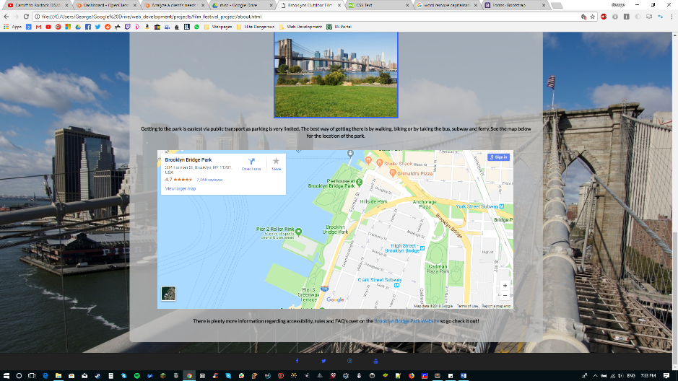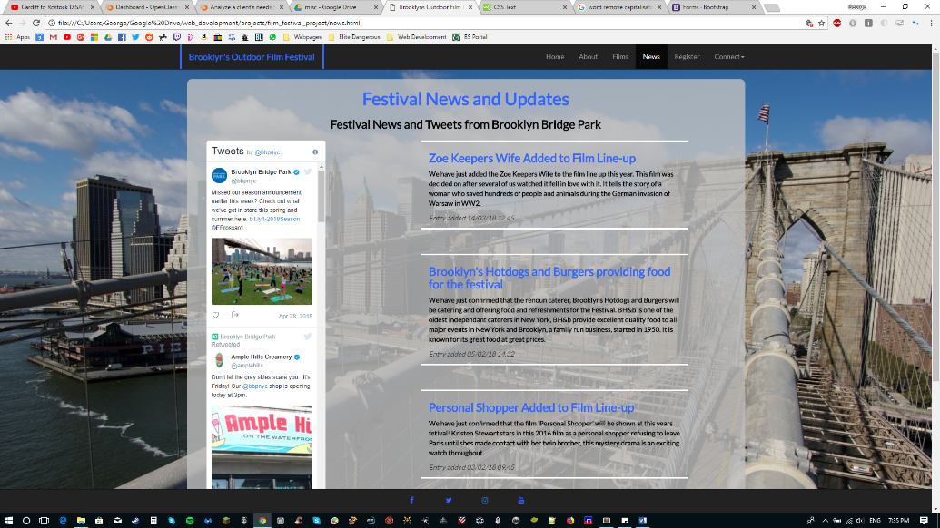And I used the Twitter widget to show Tweets from the Brooklyn Bridge Park Twitter account, this was used on the ‘News’ page.

## Having certain elements disappear on mobile

Using the Bootstrap classes and functionality I was able to tweak the layout further and remove some elements I considered as unneeded when viewing the website from a smartphone.

For example the Twitter widget I mentioned above on the ‘News’ page, I felt was just extra information and not suited for viewing on a mobile display, I therefore removed it using the ‘hidden-xs’ class.

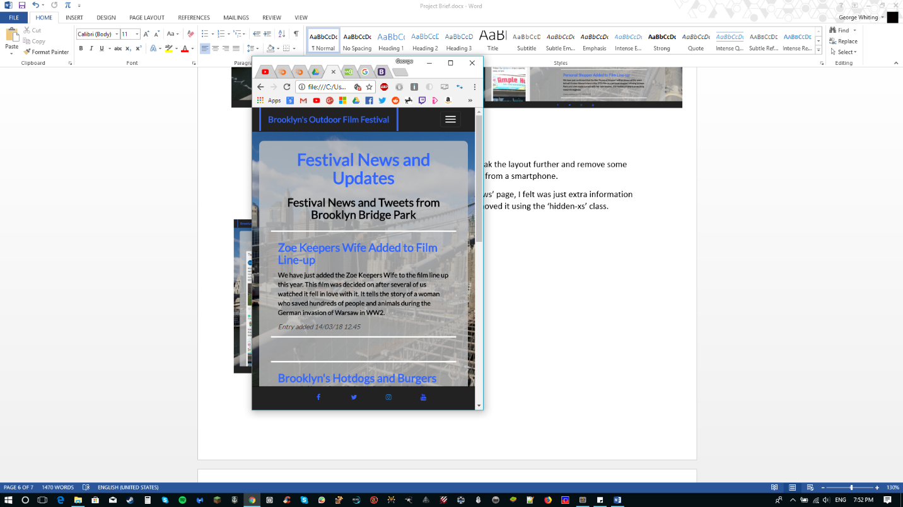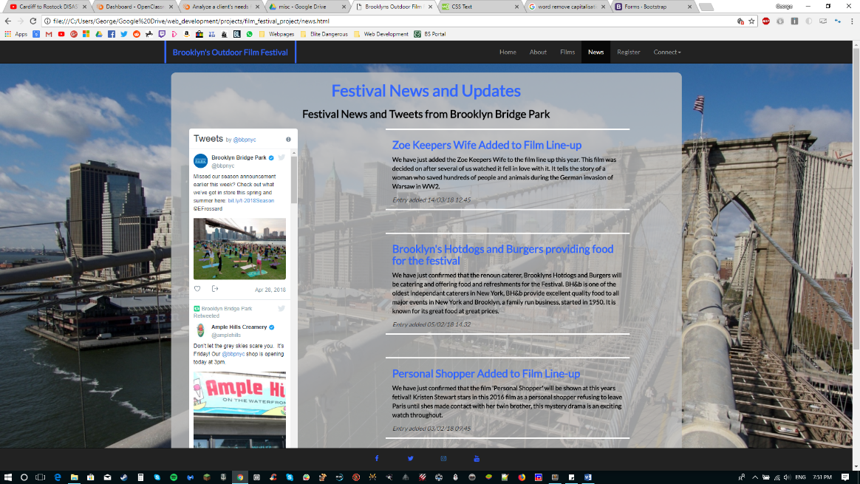

## Using a blue primary color throughout the website

In order to build a brand identity as specified in the brief, I choose to use a primary color throughout the website. This gives the website a consistent feel and builds the brand identity, I used the same light blue for the website title on the header/navbar, borders for the images, lines between separate blocks of text, social media icons in the footer and the headers throughout the site. Here’s a few reasons I choose the blue color;

* Modern and contemporary looking
* Easy to read
* Looks very good and easy to see when placed on dark backgrounds such as the navbar and footer
* Doesn’t distract the user too much from the main content

## Having the ‘Pre-Register’ element and link right on the landing page/homepage

I made the decision to place a div with the title pre-register for the festival and a link to the register page on the homepage. I did this as I felt that due to the restricted spaces at the venue and that a user needs to register before attending that this was a very important aspect of the design. The website is there to promote and display information about the venue and by directing a user to the register page straight away you have higher chance of getting plenty of people to register and attend.

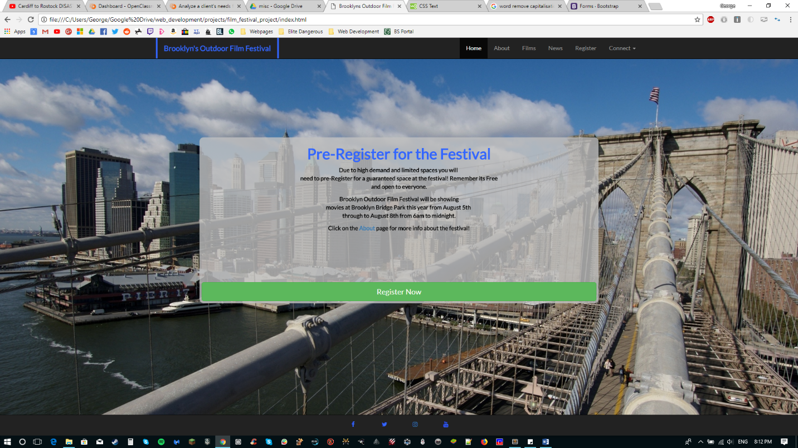

## Adding a ‘Where did you hear about us?’ section in the Pre-Register form

I added this question within the pre-register form to allow the client the gather valuable marketing information for her future film shows. By finding out where people heard about the festival you can build a useful statistic in which you can then target using ads and other methods of exposure. For example if you find that 3000 of your 5000 attendees found out about the festival through Facebook, then you know in future to target Facebook specifically in order to maximize your leads and customers.

Also if you find that only 200 people of 5000 find out about the festival through say flyers or physical promotional material, then you know for next time to take less consideration on getting flyers out, therefore saving money and time and making your budget stretch further.

## Using the ‘Lato’ font from Google Fonts

**I choose to find a font for my Website from Google Fonts, I did this for various reasons;**

* Free to use
* No license needed
* Easy to implement – simple one line of HTML and one line of CSS
* Cross platform compatibility – No matter what platform you use to view the website, the font will be available
* Increased accessibility – the user does not need the font stored on their computer to be able to see the font
* Unlimited usage – no bandwidth limitations or download caps

**I settled on the ‘Lato’ font for several reasons also;**

* Clean and easy to read
* Complete variations for different type, e.g. capitals, bold and italics
* Rounded feel to all letters, giving an easy to read and friendly feel

## Using a grey semi-transparent div for the main content areas throughout the website

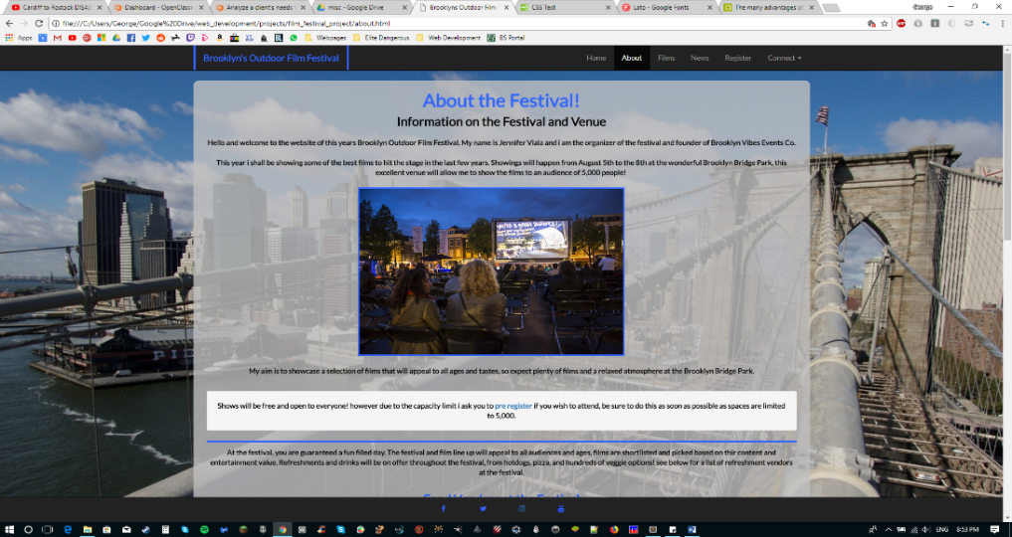Throughout the website I opted to place my text and content within a fixed width grey semitransparent div, see below:

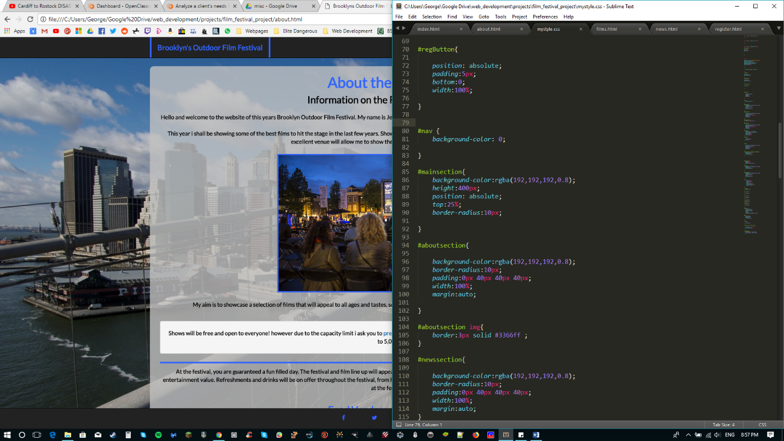This was done in order to organize my content and layout, it gives a nice area for text and images to sit and allows the content to stand out from the background image which in itself is quite bright. I rounded the edges off and gave it a neutral grey color to emphasize the text and images, In order to get it opaque I had to use the ‘rgba’ function in the CSS, by giving the div a background color of

Where **0.8** is the transparency and the rest of the numbers make up the grey color.

## Bootstrap ‘navbar’ class

I used the Bootstrap ‘navbar’ class both as the navbar and the footer for my website. The Bootstrap navbar is automatically responsive and fluid allowing for cross screen size support. The navbar reacts perfectly to a change in screen size, adjusting accordingly. In order to allow the navbar and its nav links to still be useable on a smartphone I used the collapse JavaScript plugin, this allowed me to upon resizing to a smartphone sized screen, display all the links within the navbar within a drop down ‘burger’ menu. **See below.**

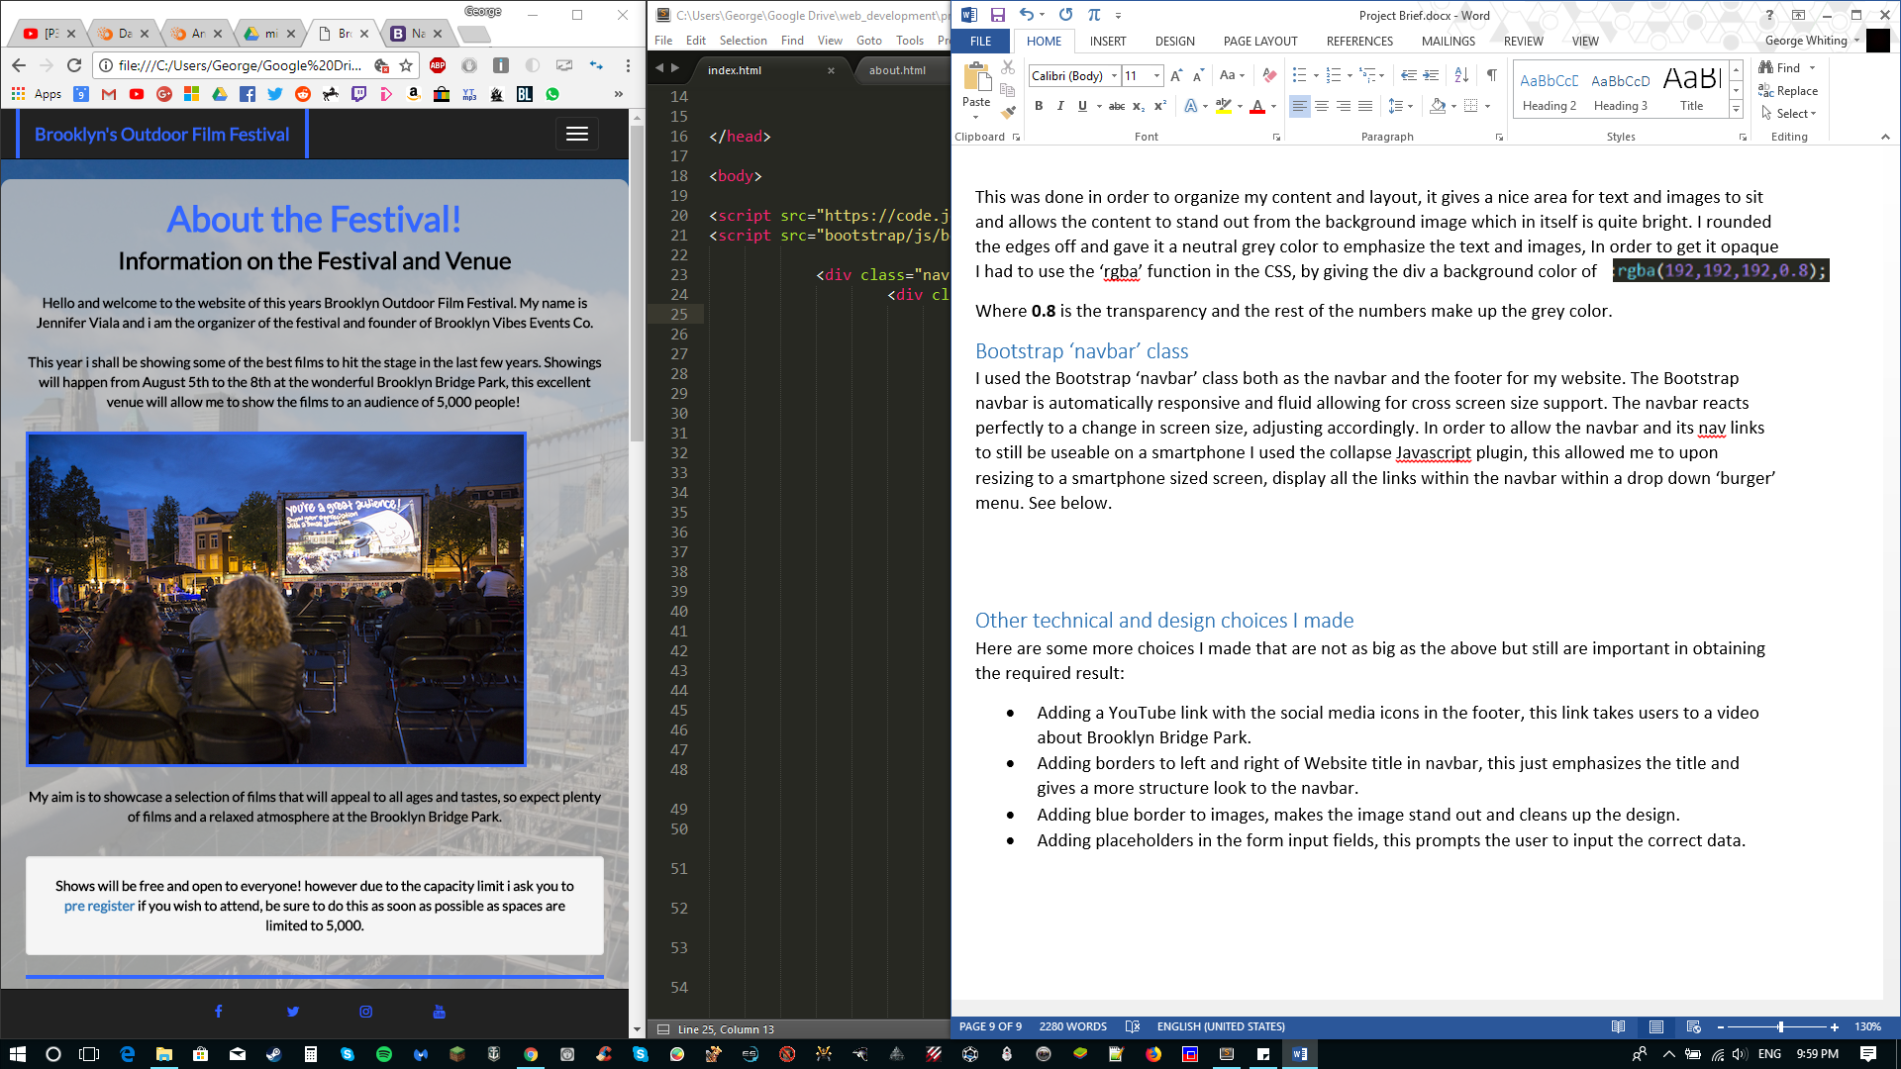

In order to get this to work I needed to add this line of code to my HTML body:

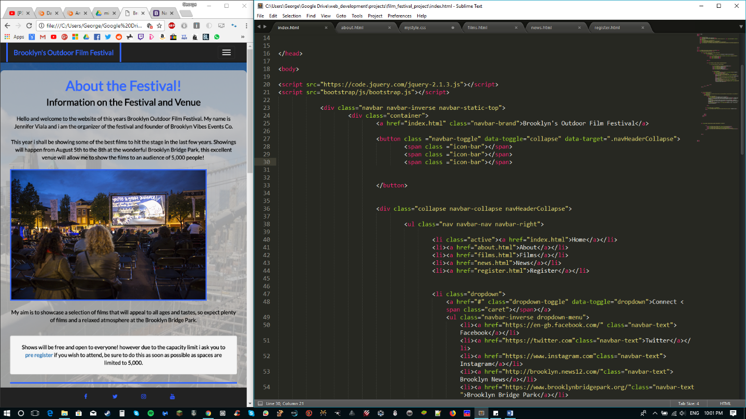

## Other technical and design choices I made

Here are some more choices I made that are not as big as the above but still are important in obtaining the required result:

* Adding a YouTube link with the social media icons in the footer, this link takes users to a video about Brooklyn Bridge Park.
* Adding borders to left and right of Website title in navbar, this just emphasizes the title and gives a more structure look to the navbar.
* Adding blue border to images, makes the image stand out and cleans up the design.
* Adding placeholders in the form input fields, this prompts the user to input the correct data.